Assessment – 4
1-program : (printing 1 to 5 with only using goto)
#include<stdio.h>
int main() {
int x=1;
loop:if(x<6)
{
printf("%d\n",x);
x=x+1;
goto loop;
}
}
2-Program : (print 5 to 1 using goto)
#include<stdio.h>
int main() {
int x=5;
loop:if(x>0)
{
printf("%d\n",x);
x=x-1;
goto loop;
}
}
3-Program : (sum of numbers 1 to 5 using goto)
#include<stdio.h>
int main() {
int x=0,sum=0;
loop:if(x<=5)
{
x=sum+1;
sum=sum+x;
goto loop;
}
printf("%d",sum);
}
4-Program : (sum of numbers 6 to 1 using goto)
#include<stdio.h>
int main() {
int x=6,sum=0;
loop:if(x>=1)
{
sum=sum+x;
x=x-1;
goto loop;
}
printf("%d",sum);
}
5-Program : (print odd numbers 1 to 9 using goto)
#include<stdio.h>
int main() {
int x=1;
loop:if( x<10 && x%2!=0)
{
printf("%d",x);
x=x+2;
goto loop;
}
}
6-Program : (print odd numbers 10 to 20 using goto)
#include<stdio.h>
int main() {
int x=11;
loop:if( x>=11 && x%2!=0 && x<20)
{
printf("%d\n",x);
x=x+2;
goto loop;
}
}
7-Program : (print 2digit odd number sum of digits are 7 using goto)
#include<stdio.h>
int main() {
int x=11,y,z;
loop:if(x<100 && (x%10 + x/10)==7 && x%2!=0)
{
printf("%d\n",x);
}
x=x+2;
goto loop;
}
8-Program : (print 2digit even number sum of digits are 6 using goto)
#include<stdio.h>
int main() {
int x=10,y,z;
loop:if(x<100 && (x%10 + x/10)==6 && x%2==0)
{
printf("%d\n",x);
}
x=x+2;
goto loop;
}

9-Program : (print 3digit odd number sum of digits are odd and 10,s is to be 7 using goto)
#include<stdio.h>
int main() {
int x=71,sum=0;
loop:if(x<80)
{
sum = sum + x;
x=x+2;
goto loop;
}
printf("%d",sum);
}
Program 10 – (To print the numbers count the user input number)
#include <stdio.h>
int main() {
int x, count = 0;
printf("Enter number: ");
scanf("%d", &x);
loop:if(x != 0)
{
x = x / 10;
count = count + 1;
goto loop;
}
printf("%d", count);
}
Program 11 – (sum of numbers )
#include <stdio.h>
int main() {
int x, y, sum = 0;
printf("Enter number: ");
scanf("%d", &x);
loop:if(x != 0)
{
y = x%10;
sum = y + sum;
x = x/10;
goto loop;
}
printf("%d", sum);
}
Program 12 – (reverse of the numbers)
#include <stdio.h>
int main() {
int x, y;
printf("Enter number: ");
scanf("%d", &x);
loop:if(x != 0)
{
y = x%10;
printf("%d", y);
x = x/10;
goto loop;
}
}
Program 13 - (interchange first and last )
#include <stdio.h>

int main() {
int x, y, z, a, b = 1;
printf("Enter number: ");
scanf("%d", &x);
y = x % 10;
a = x;
loop:if(a >= 10)
{
a = a / 10;
b = b * 10;
goto loop;
}
z = a;
a = (x % b) / 10;
x = y * b + a * 10 + z;
printf("%d", x);
}
Program 14 – (print the same if the msb is even if else it is odd then sub -1)
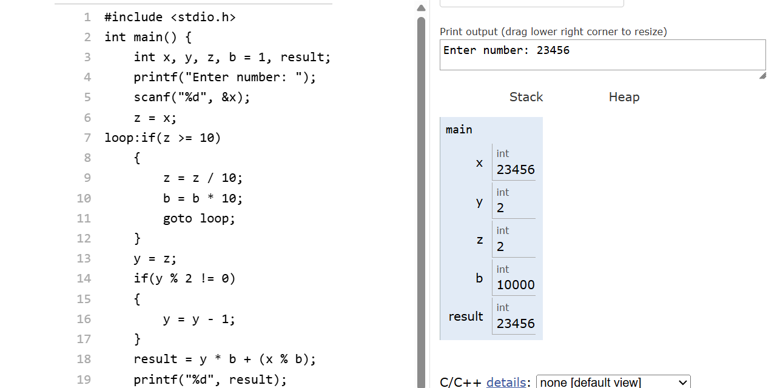
Program 15 – (prime or not a prime)
#include <stdio.h>
int main() {
int x, i = 2, flag = 0;
printf("Enter number: ");
scanf("%d", &x);
if(x <= 1)
{
printf("Not Prime");
return 0;
}
check:if(i < x)
{
if(x % i == 0)
{
flag = 1;
goto end;
}
i++;
goto check;
}
end:if(flag == 0)
printf("Prime");
else
printf("Not Prime");
}

